Khi dùng threadPoolSize=10 thì tốc độ hoàn thành 10 test case là 90s

package MuoiNamPackage;

import org.openqa.selenium.WebDriver;
import org.openqa.selenium.firefox.FirefoxDriver;
import org.testng.annotations.Test;

public class MuoiNamClass {
@Test(invocationCount=10, threadPoolSize=10)
public void wiki() {
WebDriver firefox = new FirefoxDriver();
firefox.get("https://www.wikipedia.org/");
firefox.close();
}
}

Khi không dùng threadPoolSize=10 thì tốc độ hoàn thành 10 test case là 120s. Tuy nhiên khi mở TestNG's log thì ta lại thấy nó tính cộng dồn lại nên nhìn thời gian thì có vẻ trường hợp dùng threadPoolSize mất thời gian hơn. Nhưng thực tế khi dùng threadPoolSize thì tốc độ sẽ nhanh hơn khi không dùng threadPoolSize

package MuoiNamPackage;

import org.openqa.selenium.WebDriver;
import org.openqa.selenium.firefox.FirefoxDriver;
import org.testng.annotations.Test;

public class MuoiNamClass {
@Test(invocationCount=10)
public void wiki() {
WebDriver firefox = new FirefoxDriver();
firefox.get("https://www.wikipedia.org/");
firefox.close();
}
}

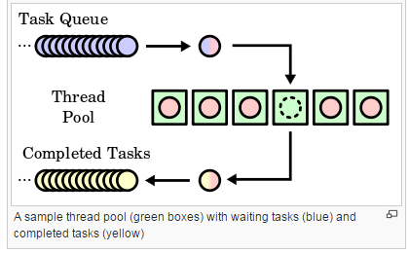
Reasons for using a thread pool, rather than the obvious alternative of spawning one thread per task, are to prevent the time and memory overhead inherent in thread creation and to avoid running out of resources such as open files or network connections (of which operating systems allocate a limited number to running programs).A common way of distributing the tasks to threads is by means of a synchronized queue. The threads in the pool take tasks off the queue, perform them, then return to the queue for their next task.

The number of threads used is a parameter that can be tuned to provide the best performance. Additionally, the number of threads can be dynamic based on the number of waiting tasks. For example, a web server can add threads if numerous web page requests come in and can remove threads when those requests taper down. The cost of having a larger thread pool is increased resource usage. The algorithm used to determine when to create or destroy threads will have an impact on the overall performance:
- create too many threads, and resources are wasted and time also wasted creating any unused threads
- destroy too many threads and more time will be spent later creating them again
- creating threads too slowly might result in poor client performance (long wait times)
- destroying threads too slowly may starve other processes of resources
The algorithm chosen will depend on the problem and the expected usage patterns.
A major advantage of using a thread pool over creating a new thread for each task is thread creation and destruction overhead is negated, which may result in better performance and better system stability. Creating and destroying a thread and its associated resources is an expensive process in terms of time. An excessive number of threads will also waste memory, and context-switching between the runnable threads also damages performance. For example, a socket connection to another machine—which might take thousands (or even millions) of cycles to drop and re-establish—can be avoided by associating it with a thread which lives over the course of more than one transaction.

